PHASE 1 – Creating a Custom Application
This phase focuses on creating a custom ServiceNow application to support the Employee Raise Issue process. It establishes the application scope and foundation for tables, modules, and further development.

Objective
Create a new scoped ServiceNow application named Employee Center.

Navigation
All menus → App Engine → ServiceNow Studio.

Steps
1. Open All menus and navigate to App Engine → ServiceNow Studio.
2. Click Create and select App.
3. Enter the application name as Employee Center.
4. Select Scope: Scoped.
5. Click Continue.
6. Return to the ServiceNow home page and reload the instance.
7. Verify that Employee Center appears as the current application.
ServiceNow Studio / Create App
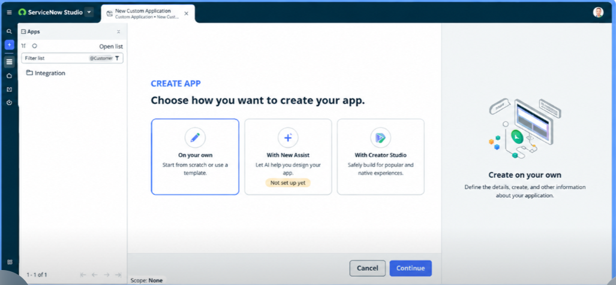
Employee Center application Scoped
